Name:___________________________

Physicist Historical Fiction Story

Directions: Read the following sections and answer the questions and prompts. All good stories follow the plot diagram model you have learned about in humanities. Use the plot diagram for your historical fiction story.

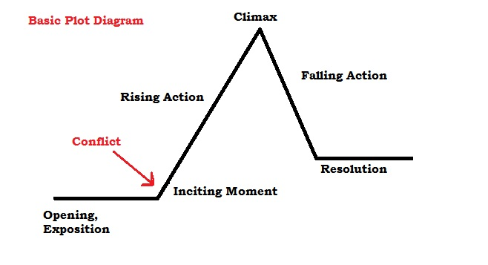
Plot diagrams begin with an introduction/expositions, a conflict, multiple rising actions, climax and resoltuion. Look at the sequence of event for the classic story Cinderella:
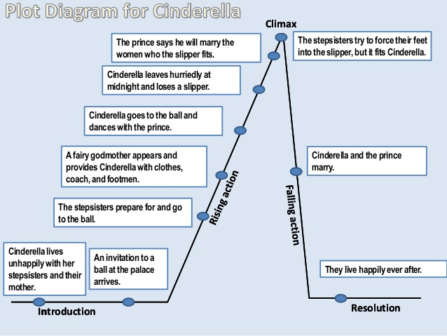
- Look at exceprt of historical fiction. Read the plot and then read the excerpt.
Read Goodnight Mama

- What specific details made the story historical? ( Names, events, specific details) ______________________________________________________________________________________________________________________________________________________________________________________________________________________________________________________________________________________________________________________________________________________________________________________________________

- What details made the story believable? ______________________________________________________________________________________________________________________________________________________________________________________________________________________________________________________________________________________________________________________________________________________________________________________________________

- What elements will help your story be believable and historically true? ______________________________________________________________________________________________________________________________________________________________________________________________________________________________________________________________________________________________________________________________________________________________________________________________________

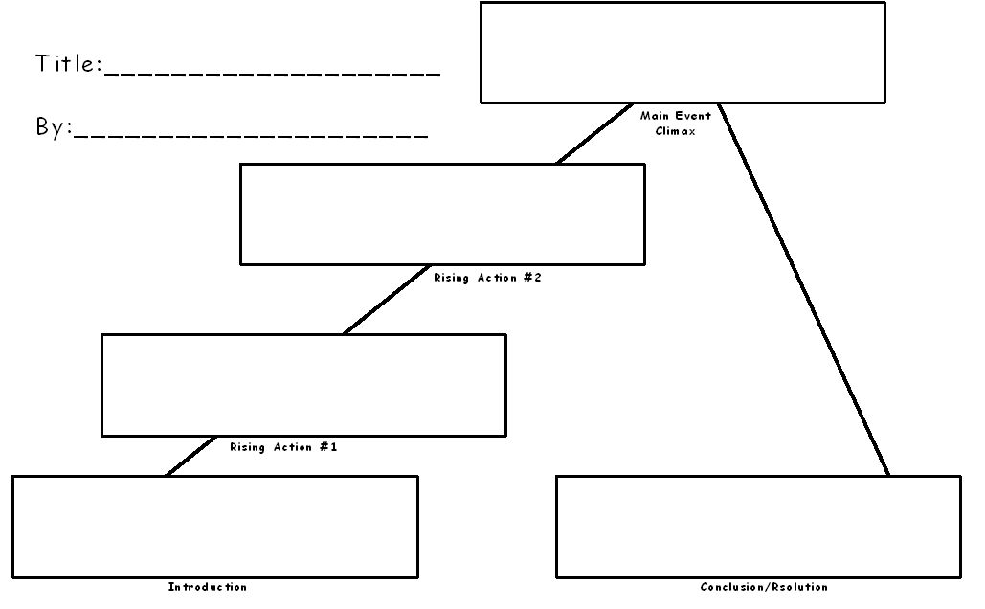
- Write in the plot diagram to create an initial idea for your historical fiction story. Write in each box your ideas. You can have more than two rising actions in your story.

- Your story has to include the following items:
  - ________(15 pts) A well written historical fiction story about your physicist that has an opening, conflict, rising action, climax and resolution
  - ________(10 pts) Write in Arial font, size 12 point, 1” margins on all sides, double spaced
  - ________(10 pts)The name of physicist and detail description about their physical appearance
  - ________(10 pts) Physicist country, cities/ other locations they lived
  - ________(15 pts) A detailed of the setting and where the story takes place when they lived (Historically true and in the correct time period)
  - ________(15 pts) 5 Interesting personal facts about the physicist
  - ________(15 pts) Explain at least one physics theory, experiment or discovery
  - ________(10 pts) Quality of Information, narrative and details
  - Total: _________/100 points

- The Opening/ Exposition: Describe the year, country, city/town, use the five senses (sight, smell, sound, touch, taste) to build the world for your story.
________________________________________________________________________________________________________________________________________________________________________________________________________________________________________________________________________________________________________________________________________________________________________________________________________________________________________________________________________________________________________________________________________________________________________________________________________________________________________________________________________________________________________________________________________________________________________________________________________________________________________________________________________________________________________________________________________________________________________

- The Characters: Describe the main characters in your story (age, gender, personality, likes/ dislikes, physical features) who were their friends, enemies, family, etc.

Character Name: ______________________________________________________________________________________________________________________________________________________________________________________________________________________________________________________________________________________________________________________________________________________________________________________________________

Character Name: ______________________________________________________________________________________________________________________________________________________________________________________________________________________________________________________________________________________________________________________________________________________________________________________________________

Character Name: ______________________________________________________________________________________________________________________________________________________________________________________________________________________________________________________________________________________________________________________________________________________________________________________________________

Character Name: ______________________________________________________________________________________________________________________________________________________________________________________________________________________________________________________________________________________________________________________________________________________________________________________________________

- The Problem/ Conflict: Describe the problem or conflict your physicist encounters. This may be a good part to include the physicist discovery, theory or struggle.
____________________________________________________________________________________________________________________________________________________________________________________________________________________________________________________________________________________________________________________________________________________________________________________________________________________________________________________________________________________________________________________________________________________________________________________________________________________________________________________________________________________________________________________________________________________________________________________________________________

- The Events: Describe the individual events in the order they occur. This is the rising action part of the story. What happens to your character? You can include the random facts about your physicist.

Event 1:
____________________________________________________________________________________________________________________________________________________________________________________________________________________________________________________________________________________________________________________________________________________________________________________________________________________________________________________________________________________

Event 2:
____________________________________________________________________________________________________________________________________________________________________________________________________________________________________________________________________________________________________________________________________________________________________________________________________________________________________________________________________________________

Event 3:
___________________________________________________________________________________________________________________________________________________________________________________________________________________________________________________________________________________________________________________________________________________________________________________________________________________________________________________________________________________

- The Climax: What is the best, most interesting point in the story? This tends to be the highest or most emotional point in the development of something. ____________________________________________________________________________________________________________________________________________________________________________________________________________________________________________________________________________________________________________________________________________________________________________________________________________________________________________________________________________________________________________________________________________________________________________________________________________________________________________________________________________________________________________________________________________________________________________________________________________________________________________________________________________________________________________________________________________________________________________________________________________________________________________________________________________________________________________________________________

- The Resolution/ The Effect: What is the outcome or ending based on the events with the conflict? How is the character changed? What resolution or conclusion happens? (This can be the area where you include awards of your physicist or how they changed as a person.) ____________________________________________________________________________________________________________________________________________________________________________________________________________________________________________________________________________________________________________________________________________________________________________________________________________________________________________________________________________________________________________________________________________________________________________________________________________________________________________________________________________________________________________________________________________________________________________________________________________________________________________________________________________________________________________________________________________________________________________________________________________________________________________________________________________________________________________________________________

- Now create a Google Document and type your story. Title it. Remember it needs to be in MLA format, Times New Roman, 12 pt font, double spaced , heading and include an opening/ exposition, conflict/ problem, at least 3 rising actions, climax and resolution. Include these:

  - Name of physicist and detail description about their physical appearance
  - Country, cities/ other locations they lived
  - Detailed of the setting and where the story takes place when they lived (Historically true and in the correct time period)
  - 5 Interesting personal facts about the physicist
  - Explain at least one physics theory, experiment or discovery

- Print out 2 copies of your story and have this packet complete for the beginning of class Thursday. I will collect it first thing.

