Note Guide: Sound waves
- What is sound?
- Sound waves are in all ______________________________
- Fluids are both ________________ and _________________________
- People can hear from ______________ Hz- _____________________________Hz
- The process of hearing is an intricate procedure.
- The Amazing Ear

- 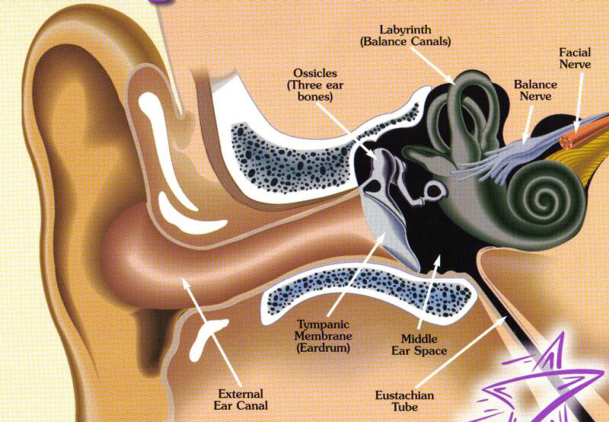
- There are sounds outside the limits of human hearing
- ______________________________: sounds with frequencies lower than 20 Hz
  - Ex: ______________________, wind, weather, __________________, cattle
- ___________________________________: sounds with frequencies higher than 20,000 Hz.
- Dogs <45,000 Hz
- Cats <70,000 Hz
- Bats <100,000 Hz

- Speed of Sound in Different Materials
Material | m/s
Air (0°ͦ) | 331
Air (20°) | 343
Helium (0°) | 972
Water (25°) | 1493
Seawater (25°) | 1533
Copper (25°) | 3560
Iron (25°) | 5130

- Find the wavelength in air at 20° C of an 18 Hz sound wave, which is one of the lowest frequencies that is detectable by the human ear.

- What is the wavelength of an 18 Hz sound wave in seawater at 25°C?

- Find the frequency of a sound wave moving through iron at 25°C with a wavelength of 1.25m.

- A 2280 Hz sound wave has a wavelength of 0.655m in an unknown medium. Identify the medium
- Speed of Sound
- The speed of sound can change based on the medium and the temperature it is propagating through.

v = (331 + 0.6T_{c})

- V = velocity (m/s)
- T = the air temperature in degrees Celsius

- Ex: On a cool October afternoon (air temp = 15 degrees) your seat on the centerfield stands 113m from first base, you watch a play at the World Series. You see the runner’s foot tag the base, half a second later you hear a baseman’s glove hit the base. Is he safe or out?

