Note Guide: Forces #3

* **Forces on a Jet**
* 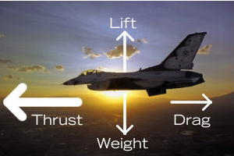
* **Horizontal and Friction Problems**
* A 20.0 kg mass is pulled by along a surface by a horizontal force of 100 N. **Friction** is 20.0 N. What is the acceleration of the mass?

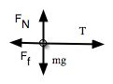

* Sum of forces (vertical forces cancel as evidenced by lack of acceleration in the vertical dimension)
* A 49-N block is pulled by a horizontal force of 50.0 N along a rough horizontal surface at a constant acceleration of 6 m/s^2. What is the **coefficient of friction**?
* In the vertical axes forces are equal and opposite as there is no vertical acceleration.
* In the vertical axes forces are equal and opposite as there is no vertical acceleration.
* **F**N = -**F**g
* FN = mg = 49 N
* m = 49/9.81 = 4.99 kg
* Obviously, if forces are vectors, they can be resolved into _________________________ as well as added.
* While the resolution of forces will not focus as much on the concepts of vertical and horizontal, the goal will be to create ­­­­­­­­­­­­­­­_____________ triangles and ease the __________________.
* **Moving up**
* An 18 kg box is secured on an incline plane at an angle of 35 degrees by string that can support 97 N of force
* A. Show mathematically whether or not the string will hold.
* B. If the string breaks and the block accelerates down the ramp, and if there is no friction, what is the acceleration of the box?
* **Friction**- a force that operates in the direction *opposite to motion* due to contact between surfaces.