Name: ___________________
Intro To Drawing
Directions: Follow the drawing prompts below and draw in the box next to the prompt.

How to Draw a Face
- Start with loose circles
- Cut circle into 4 pieces
- Curve the cut lines
- Place eyes on the centerline
- Make a mark halfway between the eyes and the bottom
- Draw a nose at the point
- Draw halfway point between nose and bottom
- Draw in mouth
- Draw in eyebrows
- Draw ears on centerline
- Match top of eyes with top of ears
- Add chin
- Add hair: start at halfway from centerline to top
- Add neck
- Erase lines
- Add details: cheeks, freckles, moles, glasses, jewelry, etc

- Begin with box below and draw a female face. B. . Fold the paper in half and draw a male face

- Begin with box below and draw your neighbor’s face. 2. Fold the paper in half and draw the same face again

- Look at the picture below and try to redraw the image in the box

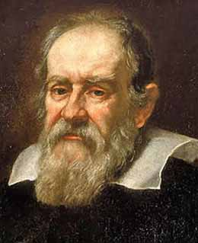

- Now look at the same picture and focus on Galileo’s nose. Draw the same picture with the exaggerated nose in the box below.
- Now look at the same picture choose a different part of Galileo’s face to exaggerate. Draw the same picture with the exaggerated feature in the box below.

